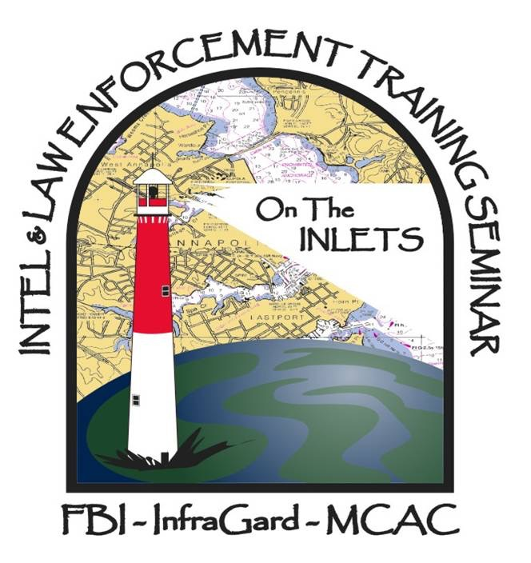
NOMINATION FORM
Above & Beyond
Scholarship Recipient

Please include the following information with each nomination for the Sponsor-a-Cop Scholarship. If this officer or civilian employee is selected, this information is essential to notify the appropriate people.

Name of Nominated Employee Title

Phone Home/Mobile Phone E-Mail

Agency

Name of person nominating the above employee Title

Phone Fax E-Mail

Person to contact if the above employee is selected Title

Phone Fax E-Mail

Signed endorsement of chief/agency head Title

NOMINATION CHECKLIST: Please make sure to turn in the following items with your nomination.

- Nomination Form
- Letter of Nomination
- Proof of act(s) to include:
  - Media Reports
  - Copies of the official report; or
  - Some other official documentation

It is recognized that confidentiality considerations may preclude the submission of reports and materials. However, there must be sufficient documentation to corroborate the overview written in the nominating letter for the nominee to be considered.

Nominations may be mailed to:
Bruce Lohr
Above and Beyond Coordinator
PO BOX 294
Annapolis, MD 21411
or Emailed to: BLohr@dpscs.state.md.us (preferred)

